**Functionality of Administrator**

The musical jazz App was built to help admin to have all control of data inside the webpage. This project is database driven application that means all information like texts and images are coming from databases system. Admin functionality is to add data, edit data, remove or delete data and view data. We implement CRUD functionality. Our admin panel page has created functionality, read functionality, update functionality and delete functionality.

**Usage step:**

1. **Login page**

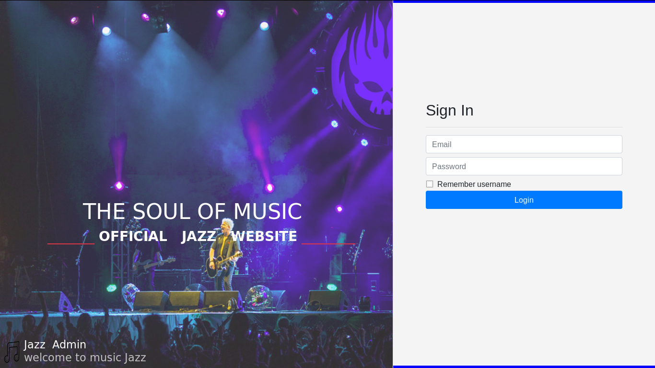

The above image indicates the login page. The admin can login the application. The will be no registration. To login into the web app admin has to follow this steps.

Step 1: enter email id (default one is [admin@gmail.com](mailto:admin@gmail.com))

Step 2: enter password (default one is admin)

Step 3: admin can click to login button

1. **Dashboard**

The images below indicate the success login page. When admin provide the correct login credential it will load a welcome dashboard to him or her.

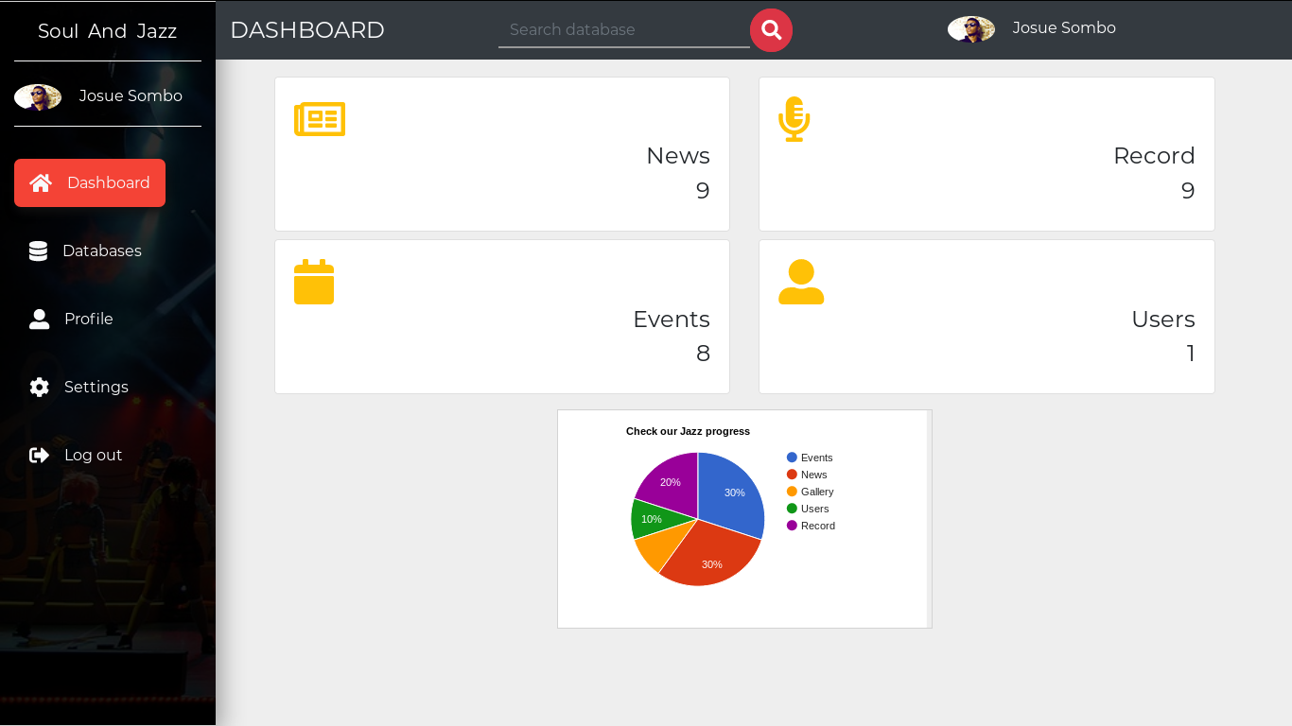

The admin dashboard has connection of all the rest of the app.

* Number 1 and 3 indicates the name of the user who login into the system.
* Number 2 indicate the search bar where admin can search for record or data name.
* Number 4 indicate number of news storing, records storing, events storing and users.
* Number 5 indicate the home page as dashboard.
* Number 6 indicate the database where admin can click to go see the entire record store for the web app.
* Number 7 indicate the user profile where admin can edit his or her credential information
* Number 8 indicate the user setting where admin can set up the language and view user detail.
* Number 9 indicate the user where to log out.

1. **Databases**

This image below shows all the important records we keep for admin to use in the Musical Jazz Official. Admin can click to any record like when Admin wants to edit news page in public page. He can click edit below the new record and start making the change.

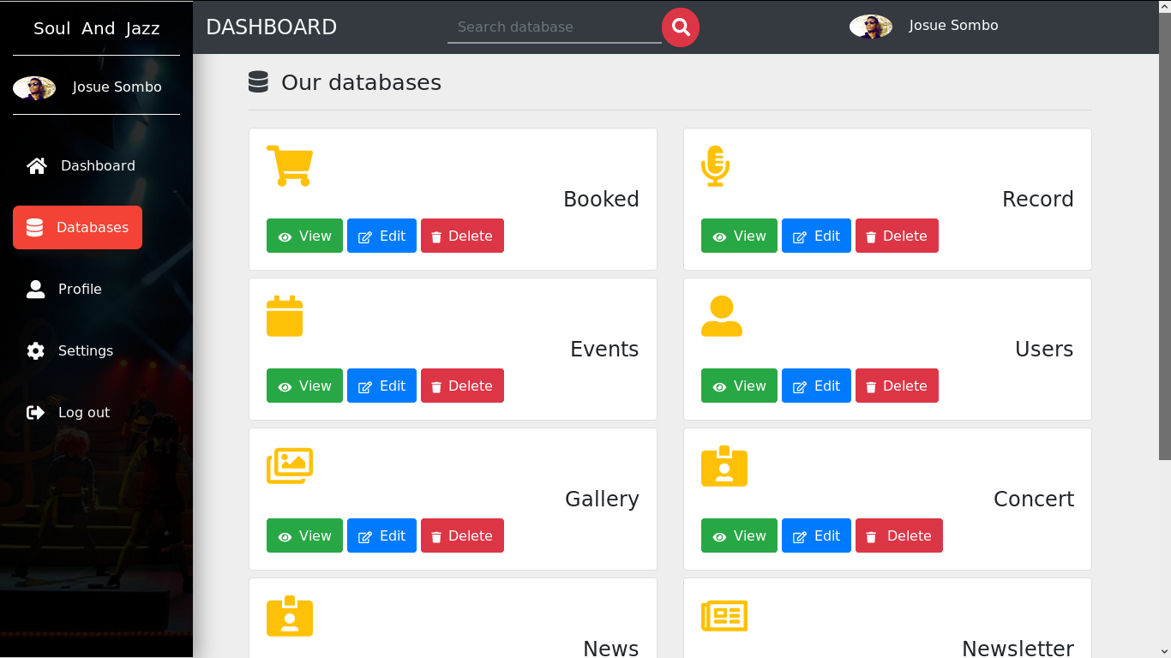

The images above display the entire record store for the public web site. This panel helps admin to edit, create, add and remove information in the public web site. All data are configure in the same way to help admin to work in the use way.

* Number 1 content Booking information for the show where admin can click to read, edit and remove data.
* Number 2 content event information for the act where admin can click to read, edit and remove event.
* Number 3 content gallery information for the act where admin can click to read, edit and remove image.
* Number 4 content record information for the act where admin can click to read, edit and remove record.
* Number 5 content user information where admin can click to read, edit and remove user.
* Number 6 content concert information for the act where admin can click to read, edit and remove concert.
* Number 7 content newsletter information for the act where admin can click to read, edit and remove data.

1. **Profile**

The image below indicates how admin can edit (email, password or images) for the account.

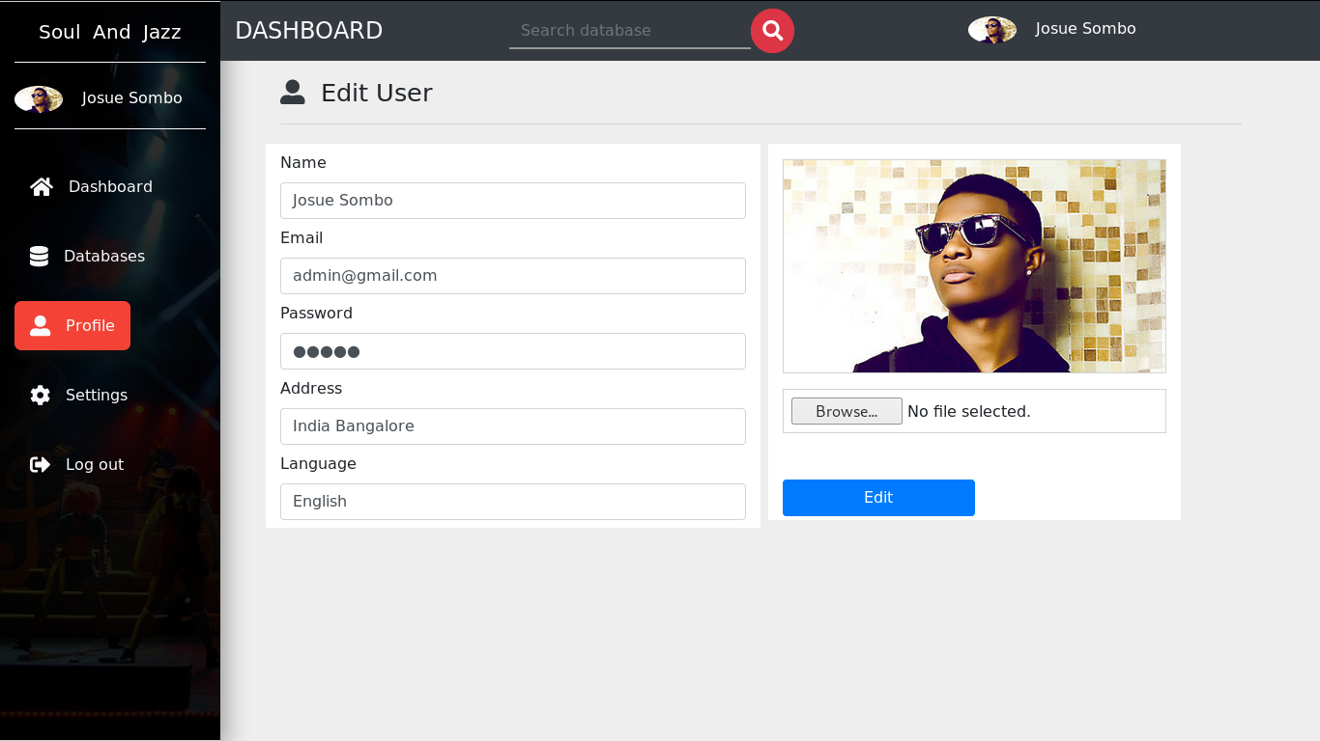

Admin can click in any field in his or her choice to change setting.

* Number 1 shows how admin could enter data into the page.
* Number 2 show how admin will submit information after finish to edit it.

1. **setting**

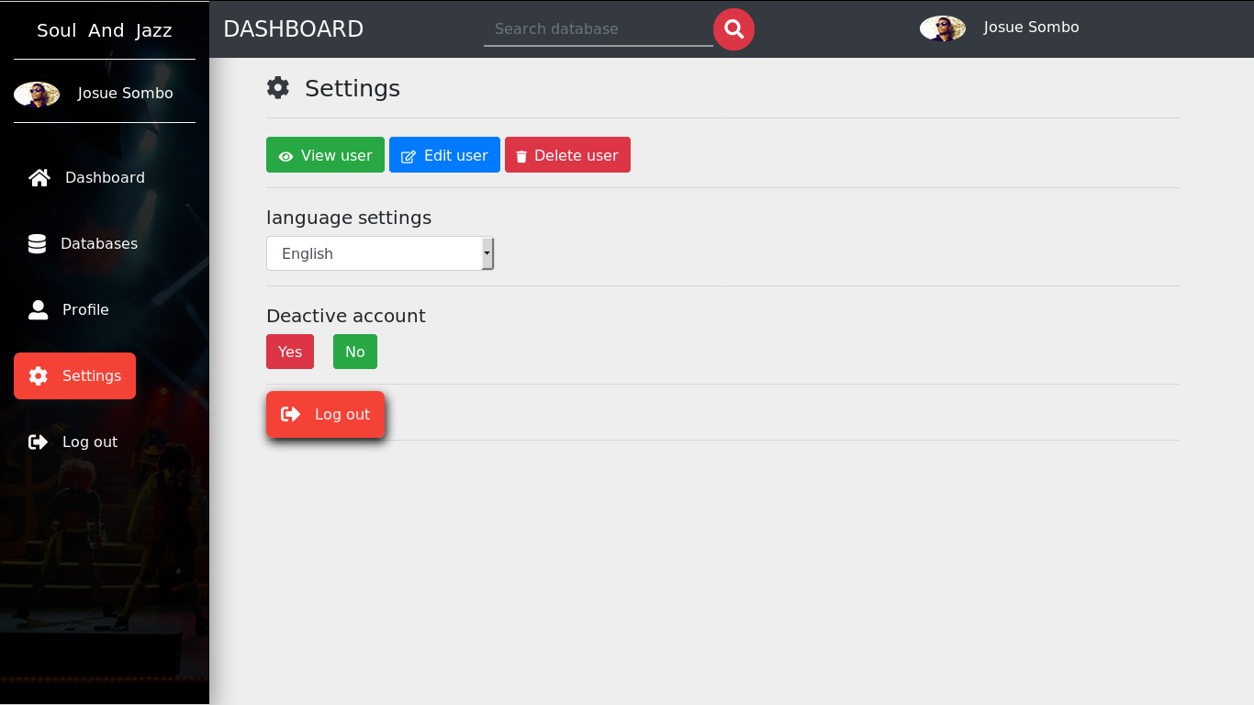

Setting section help admin to customize the website language or delete his or her account.

* Number 1 content user information where admin can click to view edit and remove user.
* Number 2 content user language setting where admin can click to change user language.
* Number 3 content delete user information where admin can click to remove it account. For security purpose admin user can not remove is account because we have only one user that can login inside the web admin panel.
* Number 4 content user logout information where admin can click to logout.

1. **NEWS RECORD**

News record store all content for news public website. Admin has all the privileges to read, add, edit and delete all the news in the public website.

How you can see news record in Admin panel.

Step 1 ->click database in left panel below dashboard ->click news (view, edit and delete)

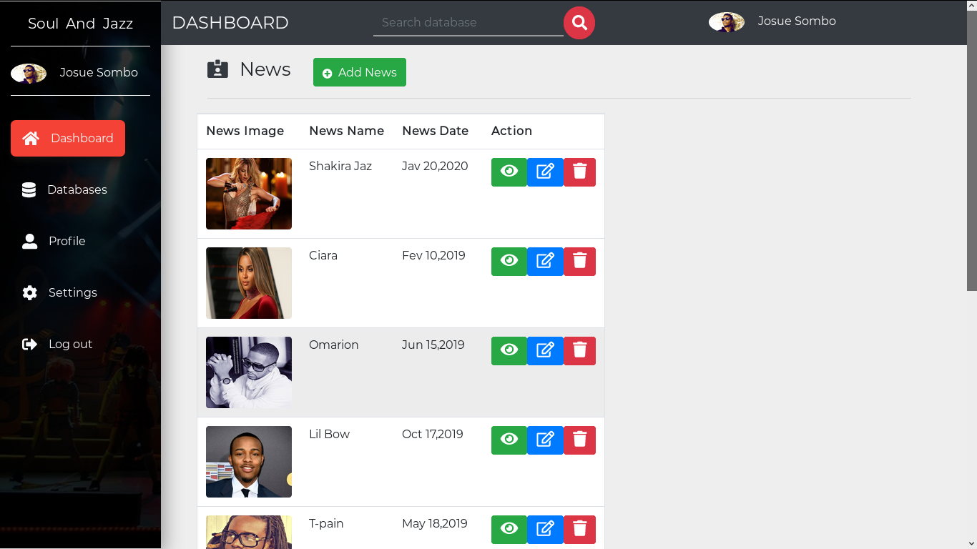

The images above display the entire news record store for the news public web site. This panel helps admin to edit, create, add and remove information in the news public web site.

* Number 1 indicates where admin can click to add news.
* Number 2 indicates where admin can click to view news.
* Number 3 indicates where admin can click to edit news.
* Number 4 indicates where admin can click to remove news.

Adding news by admin

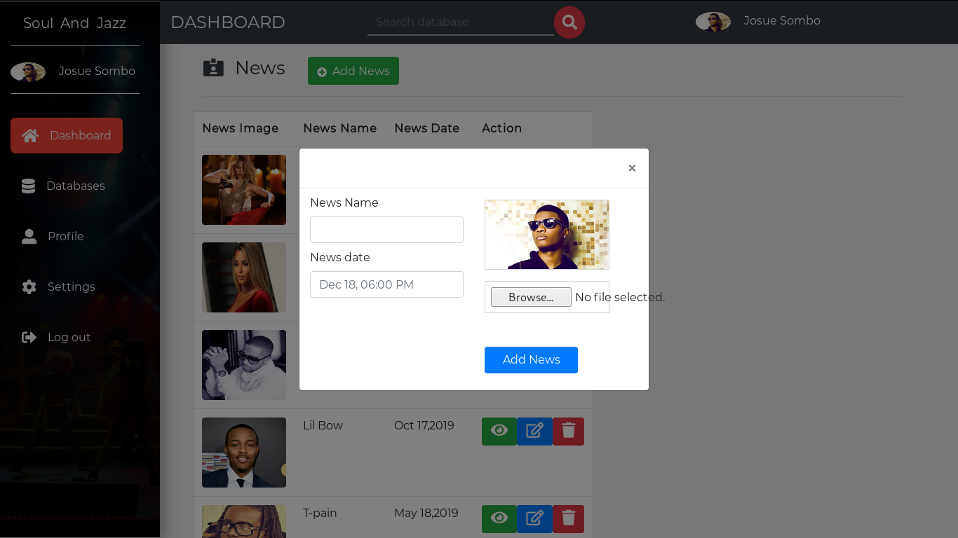

View news by admin

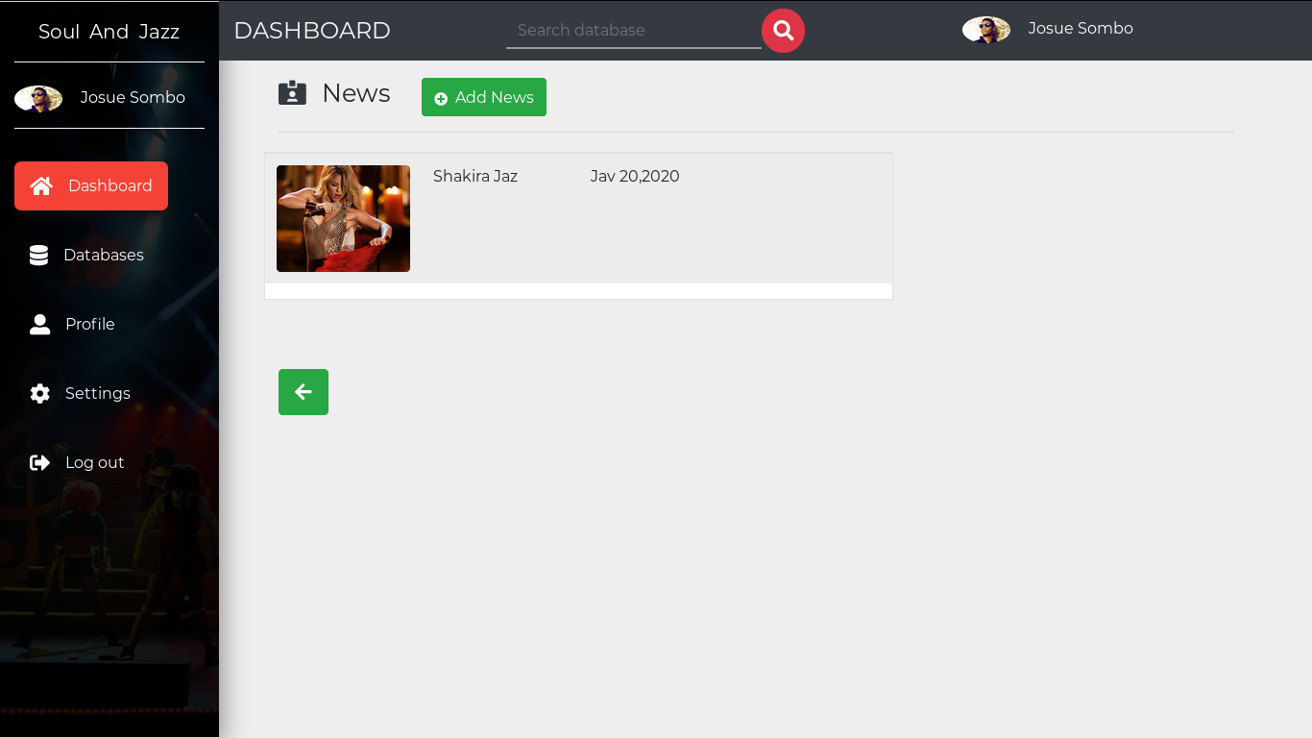

Editing news by admin

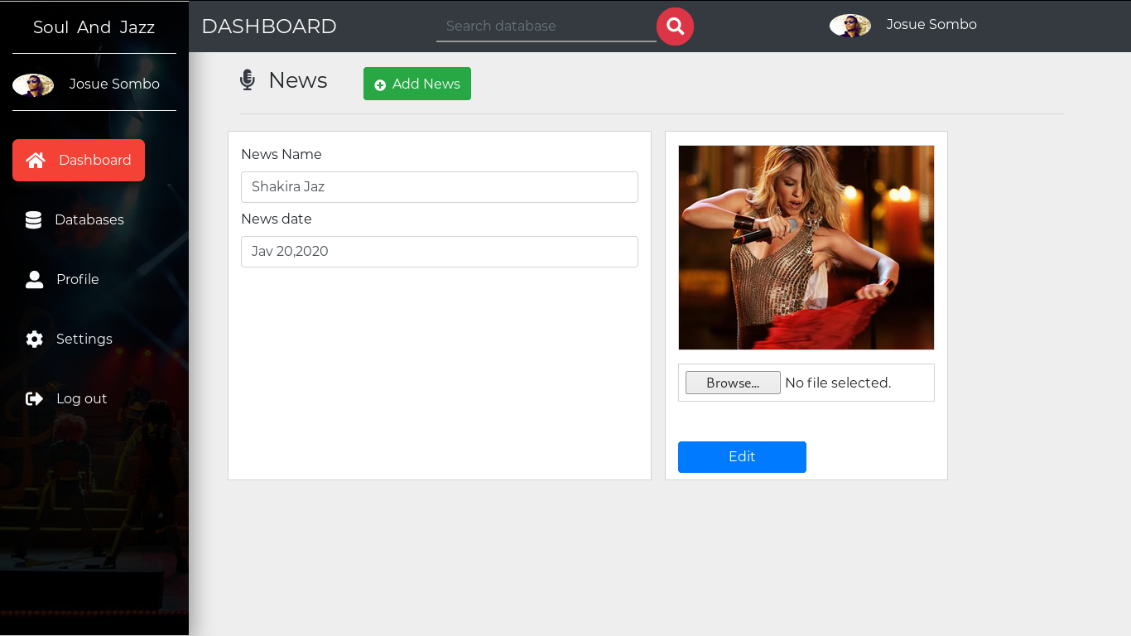

1. Act record

act record store all content for record public website. Admin has all the privileges to read, add, edit and delete all the record did by the act in the public website. How to see act record in Admin panel.

Step 1 -> click database in left panel below dashboard ->click record (view, edit and delete)

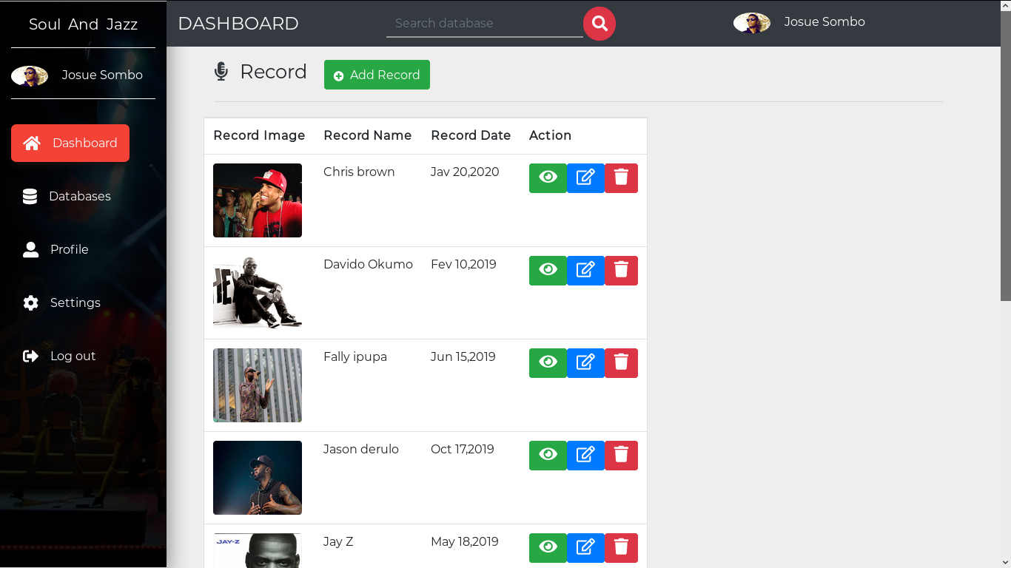

Remaining process are the same for all public web site. We design our easy tool to use for admin panel that has all the same pages configuration. Admin has just to choose which actions to do and click the icons right side the record.

Gallery record

Act record store all content for record public website. Admin has all the privileges to read, add, edit and delete all the record did by the act in the public website. How to see act record in Admin panel. Step 1 -> click database in left panel below dashboard ->click record (view, edit and delete)

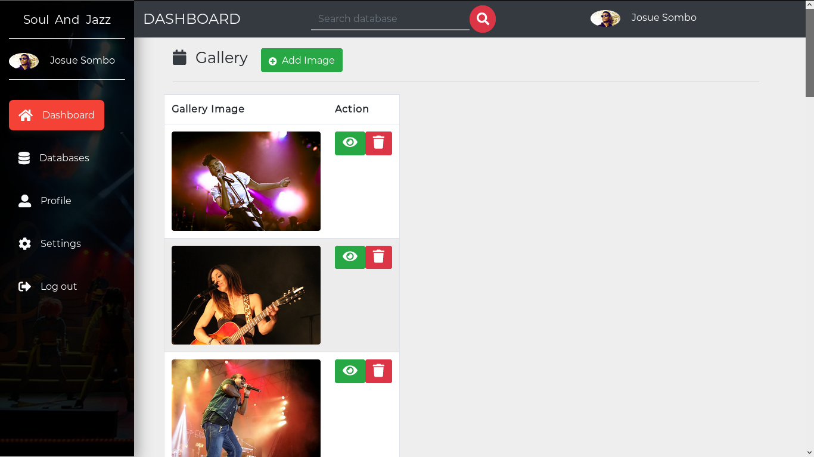

All remaining pages are configuring in the same way. Admin has only to choose which one he can make change into. For example if admin want to edit about page. He has to click to database in menu and click about to go make change.

Step -> click database in left panel below dashboard ->click about (view, edit and delete)